# SUPPLEMENTARY MATERIALS

gQSPSim: a SimBiology®-based GUI application for standardized QSP model development and application

Iraj Hosseini1,†, Justin Feigelman1,†, Anita Gajjala2, Monica Susilo1, Vidya Ramakrishnan1, Saroja Ramanujan1, and Kapil Gadkar1,\*

1 Genentech Inc., South San Francisco, CA

2 MathWorks Inc., Consulting Services, Natick, MA

† IH and JF are co-first authors

\* Corresponding author (email: gadkar.kapil@gene.com)

## Instructions S1: TMDD Model

***Requirements:***

Session folder contains the following files:

* SimBiology® project file: casestudy1\_TMDD\_template.sbproj
* Dataset files: Data\_mean.xlsx
* Parameter files: Param\_7.xlsx and Param\_8.xlsx
* Acceptance Criteria files: AC\_vpop\_var\_target.xlsx and AC\_vpop\_fixed\_target.xlsx
* Target Statistics files: Data\_mean\_vpop\_gen.xlsx
* Virtual Subject(s) files: Vpop\_orig\_group.xlsx
* Other files: Data\_vpop\_init\_val.xlsx

***Instructions for session file set-up:***

* Open the QSP App by running QSPapp.m file
* Click on File > New
* Click on untitled to see the summary view (empty), click on the ‘Pencil Icon’ to edit
* Name the session file as ‘CaseStudy1\_TMDD’ within the ‘Name’ feature
* For Root Directory, click on the Folder symbol and select the folder that contains the model and data files
* ‘Objective Functions Directory’, ‘User-defined Functions Directory’, and ‘Autosave Directory’ default to the same location as that of the root directory
* Select ‘Autosave options’ as suited and click ‘OK’

***1.1. Instructions for Optimization:***

* Create the building blocks for Optimization
  + *Tasks:* 
    - Right click ‘Tasks’ in the left panel to select ‘Add new Task’
    - Select ‘New Task’ and click on the ‘Pencil Icon’ to edit the Task
    - Select ‘casestudy1\_TMDD\_template.sbproj’ under the Project feature and select the TMDDmodel under ‘Model’ feature
    - Rename the Task to ‘A\_3.0 mpk’ within the ‘Name’ feature
    - Under ‘Variants to activate’, select ‘Ref values – treatment A – KD = 0.4’ and then click -> to add it to the right panel
    - Under ‘Doses to include’, select ‘3 mg/kg’
    - Under ‘Species to include’, select ‘UnboundAbConc (mcg/ml)’, ‘FreeTarget (ng/ml)’, ‘TotalTarget (ng/ml)’, and ‘s\_target\_init’
    - Under the Settings -> Output Times: set the time to [0:0.1:21] and uncheck the ‘Run to Steady State’ feature
    - Click OK to save
    - Follow the same steps to create another Task similarly for ‘A\_0.3 mpk’ or duplicate the previous Task by right clicking and use 0.3 mg/kg dose instead of 3.0 mg/kg and save the Task.
  + *Datasets:* 
    - Right click ‘Datasets’ in the left panel to select ‘Add new Dataset’
    - Select ‘New Dataset’ and click on the ‘Pencil Icon’ to edit
    - Rename the data to ‘Data\_mean’ within the ‘Name’ feature
    - Load the ‘Data\_mean.xlsx’ file under the ‘File’ feature
    - Select ‘wide’ as File Type
    - Click ‘OK’ to save
  + *Parameters:* 
    - Right click ‘Parameters’ in the left panel to select ‘Add new Parameter’
    - Select ‘New Parameters’ and click on the ‘Pencil Icon’ to edit
    - Rename the Parameter file to ‘Param\_8’ within the ‘Name’ feature
    - Load ‘Param\_8.xlsx’ file under the ‘File’ feature
    - Click ‘OK’ to save
    - Note the ‘No of Parameters’ in the Summary view
* Optimization
  + Expand ‘Functionalities’ to see ‘Optimizations’
  + Right click ‘Optimizations’ in the left panel to select ‘Add new Optimization’
  + Select ‘New Optimization’ and click on the ‘Pencil Icon’ to edit
  + Rename to ‘Optimization’ within the ‘Name’ feature
  + Select the appropriate folder to assign to the ‘Results Path’ feature. Optimization results will be saved here. Once the Optimization is done, the results will automatically appear under ‘Virtual Subject(s)’ within the ‘Building blocks’
  + Select ‘ScatterSearch’ within the ‘Algorithm’ feature
  + Select ‘Param\_8’ within the ‘Parameters’ feature and ‘Data\_mean’ within the ‘Dataset’ feature
  + Note the ‘Parameters’ table is populated with the list of parameters to be estimated
  + Select ‘Group’ and ‘ID’ within the ‘Group Column’ and ‘ID Column’ features
  + Add the two tasks to ‘Optimization Items’ and map to the appropriate Groups from the Dataset
    - Task: A\_3.0 mpk 🡪 Group: 1
    - Task: A\_0.3 mpk 🡪 Group: 2
  + In the Species-Data Mapping, add the followings:
    - Data: pk\_free\_ugm 🡪 Species: UnboundAbConc (mcg/ml)
    - Data: target\_free\_ngml 🡪 Species: FreeTarget (ng/ml)
    - Data: target\_tot\_ngml 🡪 Species: TotalTarget (ng/ml)
  + Leave ‘Species Initial Conditions’ table blank
  + Click ‘OK’, click the green run button. A progress bar will appear while the optimization is in progress. Once done, click the visualize button
  + Select plot layout as 2x2
  + Use the ‘Species-Data’ table to assign species ‘FreeTarget (ng/ml)’, ‘TotalTarget (ng/ml)’, and ‘UnboundAbConc (mcg/ml)’ to plot numbers 2, 1, and 3, respectively
  + Check the ‘Include’ boxes from the ‘Optimization Items’ table to visualize the data in the plots
  + Add a run to the ‘Run Profiles’ table and select the results for Optimization within the Source dropdown menu
  + Click the ‘Apply’ icon in the bottom right
  + Take note of the parameter values listed
  + The user can also use other optimization methods to compare the results. To do so, edit the optimization and change the method to another one, e.g., ParticleSwarm algorithm. Re-run and overlay the results in the visualization view
  + Compare the results of both optimization methods with the results shown in Figure 3.

***1.2. Instructions for Virtual Cohort Generation***

* Create the building blocks for Virtual Cohort Generation
  + *Tasks and Parameters*: The same as what was used for the Optimization
  + *Acceptance Criteria:*
    - Right click ‘Acceptance Criteria’ in the left panel to select ‘Add new Acceptance Criteria’
    - Select ‘New Acceptance Criteria’ and click on the ‘Pencil Icon’ to edit
    - Rename to ‘AC\_fixed\_target’ within the ‘Name’ feature
    - Load ‘AC\_vpop\_fixed\_target.xlsx’ file under the ‘File’ feature
    - Click ‘OK’ to save
* Generating a Virtual Cohort
  + Within ‘Functionalities’, right click ‘Virtual Cohort Generations’ to select ‘Add new Cohort Generation’
  + Select ‘New CohortGeneration’ and click on the ‘Pencil Icon’ to edit
  + Rename to ‘Cohort\_fixed\_target\_1000’ within the ‘Name’ feature
  + Select the appropriate folder to assign to the ‘Results Path’ feature. Virtual Cohort Generation results will be saved here. Once this is done, the results can also be found under ‘Virtual Subject(s)’ within the ‘Building blocks’
  + Select ‘Param\_8’ within the ‘Parameters’ feature, ‘AC\_fixed\_target’ within the ‘Acceptance Criteria’ feature, and ‘group’ within the ‘Group Column’
  + Note the ‘Parameters’ table is populated with the list of parameters to be varied
  + Enter ‘Max# of Sims=5000’ and ‘Max# of Virtual Subjects=500’
  + Select ‘Save preference’ method to ‘Save all virtual subjects’ or ‘Save valid virtual subjects’. Try both methods and examine the two result files saved
  + Select ‘Search Method’ to ‘Distribution’
  + Add the two tasks to ‘Virtual Cohort Items’ and map to the appropriate Groups from the Acceptance Criteria
    - Task: A\_3.0 mpk 🡪 Group: 1
    - Task: A\_0.3 mpk 🡪 Group: 2
  + In the Species-Data Mapping, add the followings:
    - Data: pk\_free\_ugm 🡪 Species: UnboundAbConc (mcg/ml)
    - Data: target\_free\_ngml 🡪 Species: FreeTarget (ng/ml)
    - Data: target\_tot\_ngml 🡪 Species: TotalTarget (ng/ml)
  + Leave ‘Initial Conditions Path’ empty
  + Click ‘OK’ to save, click the green run button, and click the visualize button
  + Select plot layout as 2x2.
  + Plot type specifies visualization in normal and diagnostic view
  + Use the ‘Species-Data’ table to assign species ‘FreeTarget (ng/ml)’, ‘TotalTarget (ng/ml)’, and ‘UnboundAbConc (mcg/ml)’ to plot numbers 2, 1, and 3, respectively
  + Check the ‘Include’ boxes from the ‘Virtual Cohort Items’ table to visualize the results and Acceptance Criteria in the plots
  + Check the ‘Show Invalid Virtual Subjects’ feature to visualize the invalid Virtual Subjects in the plots (compare with Supplementary Figure S11)
  + Click on ‘Diagnostic’ view to see the variability in the Virtual Cohort at each time point compared to the Acceptance Criteria (compare with Supplementary Figure S9)
  + Click on ‘Parameter Distribution Diagnostics’ button to plot the parameter distribution of the Virtual Cohort (compare with Supplementary Figure S10)

***1.3. Instructions for Virtual Population Generation***

* Create the building blocks for Virtual Population Generation
  + *Tasks* 
    - The tasks used to build the Virtual Population are the same as the Optimization section
  + *Target Statistics*
    - Right click on ‘Target Statistics’ in the ‘Building blocks’ to add ‘New Target Statistics’
    - Select ‘New Target Statistics’ and click on the ‘Pencil Icon’ to edit
    - Rename the data to ‘Data\_with\_mean’ within the ‘Name’ feature
    - Load the ‘Data\_mean\_vpop\_gen.xlsx’ file under the ‘File’ feature
    - Click ‘OK’ to save
* Generating a Virtual Population
  + Right click on ‘Virtual Population Generations’ in the left panel to select ‘Add new Virtual Population Generation’
  + Select ‘New VirtualPopulationGeneration’ and click on the ‘Pencil Icon’ to edit
  + Rename to ‘VP\_mean\_data’ within the ‘Name’ feature
  + Select the appropriate folder to assign to the ‘Results Path’ feature. Virtual Population Generation results will be saved here. Once this is done, the results can also be found under ‘Virtual Subject(s)’ within the ‘Building blocks’
  + Select the appropriate Virtual Cohort results from the ‘Cohort\_fixed\_target\_1000’ within the ‘Virtual Cohort’ feature
  + Select ‘Data\_with\_mean’ within the ‘Target Statistics’ feature
  + Select ‘Group’ within the ‘Group Column’ feature
  + Select 100 for the ‘Minimum # of Virtual Subjects’ feature
  + Check the box to select ‘Maximize Virtual Population diversity’
  + Add the two tasks to ‘Virtual Population Items’ and map to the appropriate Groups from the Target Statistics
    - Task: A\_3.0 mpk 🡪 Group: 1
    - Task: A\_0.3 mpk 🡪 Group: 2
  + In the Species-Data Mapping, add the followings:
    - Data: pk\_free\_ugm 🡪 Species: UnboundAbConc (mcg/ml)
    - Data: target\_free\_ngml 🡪 Species: FreeTarget (ng/ml)
    - Data: target\_tot\_ngml 🡪 Species: TotalTarget (ng/ml)
  + Click ‘OK’ to save, run, and visualize
  + Select plot layout as 2x2
  + Use the ‘Species-Data’ table to assign species ‘FreeTarget (ng/ml)’, ‘TotalTarget (ng/ml)’, and ‘UnboundAbConc (mcg/ml)’ to plot numbers 2, 1, and 3, respectively
  + Check the ‘Include’ boxes from the ‘Virtual Population Items’ table to visualize the results and Target Statistics in the plots
  + Compare with Figure 3.

***1.4. Instructions for Simulation:***

* Create the building blocks for simulation
  + *Tasks:* Similar to above, create four new tasks with the following specifications:

|  |  |  |
| --- | --- | --- |
| **Name** | **Doses to include** | **Output Times** |
| A\_0.3 mpk\_S | 0.3 mg/kg | [0:0.1:49] |
| A\_3 mpk\_S | 3.0 mg/kg | [0:0.1:49] |
| A\_1 mpk\_M | 1.0 mg/kg\_3 | [0:0.1:49] |
| A\_10 mpk\_M | 10 mg/kg\_3 | [0:0.1:49] |

* *Running a Simulation*
  + Right click on ‘Simulations’ in the left panel to select ‘Add New Simulation’
  + Select ‘New Simulation’ and click on the ‘Pencil Icon’ to edit
  + Rename to ‘Sim\_Cohort\_fixed\_target\_1000 VP’ within the ‘Name’ feature
  + Select the ‘Data\_mean’ as the ‘Dataset’ feature and select ‘Group’ with ‘Group Column’ feature
  + Add the Tasks created above to the ‘Simulation Items’ table and select the results from the Virtual Population generated above in the ‘Virtual Subject(s)’ column.

|  |  |  |  |
| --- | --- | --- | --- |
| **Task** | **Virtual Population** | **Simulation Group** | **Available Group** |
| A\_0.3 mpk\_S | Results:Vpop | [blank] | N/A |
| A\_3 mpk\_S | Results:Vpop | [blank] | N/A |
| A\_1 mpk\_M | Results:Vpop |  |  |
| A\_10 mpk\_M | Results:Vpop |  |  |

* + Click ‘OK’ to save
  + Click the ‘Play’ icon to run the simulation
  + After the simulation runs successfully, click the ‘Graph’ icon to visualize the simulation
  + Click ‘Plot Layout’ feature to choose 2x2 layout
  + Use the ‘Species’ table to assign species ‘FreeTarget (ng/ml)’, ‘TotalTarget (ng/ml)’, ‘UnboundAbConc (mcg/ml)’, and ‘s\_target\_init’ to plot numbers 1, 3, 2, and 4, respectively.
  + Check the ‘Include’ boxes from the ‘Simulation Items’ table to visualize the results
  + Assign plot number to data columns within the ‘Data’ table
  + Check the ‘Include’ boxes from the ‘Group (dataset)’ table to visualize the data
  + Compare with Figure 3.

***1.5.*** ***Instructions for supplementary plots***

*Virtual Cohort Generation with group-specific initial target concentrations*

* Add a new Parameter named ‘Param\_7’ and load ‘Param\_7.xlsx’
* Add a new Acceptance criteria named as ‘AC\_var\_target’ and load ‘AC\_vpop\_var\_target.xlsx’
* Follow the Virtual Cohort Generation steps mentioned earlier using the ‘Param\_7’ for the Parameter and ‘AC\_vpop\_var\_target’ for the Acceptance Criteria
* Assign Tasks ‘A\_3.0 mpk’ and ‘A\_0.3 mpk’ to groups 4 and 5, respectively (these are groups from the Acceptance Criteria files)
* Load ‘Data\_vpop\_init\_val.xlsx’ in the ‘Initial Conditions Path’ feature
* Click ‘OK’ to save, run, and visualize
* Compare with Supplementary Figure S12.

*Simulation (model default)*

* Right click ‘Simulations’ in the left panel to select ‘Add New Simulation’
* Select ‘New Simulation’ and click on the ‘Pencil Icon’ to edit
* Rename to ‘Sim\_model\_default’ within the ‘Name’ feature
* Select the ‘Data\_mean’ as the ‘Dataset’ feature and select ‘Group’ with ‘Group Column’ feature
* Add the two Tasks created above to the ‘Simulation Items’ table and select ‘Model Default’ in the ‘Virtual Subject(s)’ column
  + Task: A\_3.0 mpk 🡪 Virtual Population: Model Default
  + Task: A\_0.3 mpk 🡪 Virtual Population: Model Default
* Click ‘OK’ to save
* Click the ‘Play’ icon to run the simulation
* After the simulation runs successfully, click the ‘Graph’ icon to visualize the simulation
* Click ‘Plot Layout’ feature to choose 2x2 layout
* Use the ‘Species’ table to assign species ‘FreeTarget (ng/ml)’, ‘TotalTarget (ng/ml)’, ‘UnboundAbConc (mcg/ml)’, and ‘s\_target\_init’ to plot numbers 1, 3, 2, and 4, respectively.
* Check the ‘Include’ boxes from the ‘Simulation Items’ table to visualize the results
* Assign plot number to data columns within the ‘Data’ table
* Check the ‘Include’ boxes from the ‘Group (dataset)’ table to visualize the data
* Compare with Supplementary Figure S8.

*Simulating Virtual Population with group-specific information*

* Right click on ‘Virtual Subjects(s)’ within ‘Building blocks’ to select ‘Add new Virtual Subject(s)’
* Select ‘New Virtual Subjects’ and click on the ‘Pencil Icon’ to edit
* Rename to ‘VP\_org\_group’ within the ‘Name’ feature
* Load the ‘Vpop\_orig\_group.xlsx’ file under the ‘File’ feature
* Switch to Simulation and duplicate the previous simulation (‘Sim\_model\_default’) by right clicking on the Simulation name. Then, rename the Simulation to ‘Sim\_VP\_org\_group’. In the ‘Simulation Items’ table, change ‘Model Default’ to ‘VP\_org\_group’ for both rows and select the appropriate group for ‘Virtual Subject Group to Simulate’ column.

|  |  |  |  |
| --- | --- | --- | --- |
| **Task** | **Virtual Subject(s)** | **Virtual Subject Group to Simulate** | **Available Groups in Virtual Subjects** |
| A\_3.0 mpk | VP\_org\_group | 1 | 1,2 |
| A\_0.3 mpk | VP\_org\_group | 2 | 1,2 |

* Click ‘OK’ to save, run and then visualize the simulation as before
* Compare with Supplementary Figure S13.

## Instructions S2: anti-PCSK9 QSP model

***Requirements***

Session folder contains the following files:

* SimBiology® project file: antiPCSK9\_gadkar\_v3.sbproj
  + User-defined functions called in the SimBiology® project file (SREBP2\_reg.m, and transform.m) are located in the UDF folder
* Dataset files:
  1. DataFiles\data\_allsingledose.xlsx
  2. DataFiles\data\_modelvalidation.xlsx
* Parameters files (see Table S7 for parameter description):
  1. ParamFiles\Parameters\_foroptim.xlsx
  2. ParamFiles\Parameters\_forCohortGen.xlsx
* Acceptance Criteria file: ACFiles\AC\_alldose.xlsx
* Virtual Subject(s) file: VPopFiles\VPOP\_100Random\_Check\_SteadyState\_range.xlsx
* Target Statistics file: TargetStatsFiles\Data\_mean\_std\_vpop\_gen\_v2.xlsx
* Supplementary MATLAB® code for plotting:
  + Plotting\_validation\Plot\_Validation\_comparetodata\_v6\_forMac.m
  + Plotting\_validation\Plot\_Validation\_comparetodata\_v6\_forWindows.m
* Session file: CaseStudy2\_pcsk9.qsp.mat

***Instructions for session file set-up:***

* + Create a new session file and save it as casestudy2\_pcsk9.qsp.mat
  + In the session settings:
    - Name the session: ‘Case Study 2: aPCSK9’
    - Select the root directory: path of the session folder
    - Leave Objective Functions Directory blank since this example does not use a custom user-defined objective function
    - Select User-defined Functions Directory: UDF
    - Parallel options (optional): if your computer is capable of parallel computing and you have Parallel Computing Toolbox for MATLAB® installed, check this box. Otherwise leave unchecked.
    - Autosave options (optional): if you would like the app to autosave your session file periodically or every time before running one of the functionalities, check the preferred option and specify the autosave directory.
  + Save the session file

***2.1. Instructions for running Simulations to find time to steady state***

* Create the building blocks for this simulation:
  + *Tasks*: simulate without dose for 1000 days
    - Add a new Task
    - Rename the Task to ‘No Dose’
    - Choose the SimBiology® project file antiPCSK9\_gadkar\_v3.sbproj
    - Activate the variant TMDD\_calibration
    - Leave ‘Doses to Include’ blank
    - Add the following species: total\_pcsk9, LDLch
    - Change the Output Times to: [0:1:1000]
    - Uncheck ‘Run to Steady State’
  + *Virtual Subject(s)*:
    - Add a new Virtual Subject(s) object
    - Rename the building block as VPOP\_100VS\_CheckSS
    - Choose the VPopFiles\VPOP\_100Random\_Check\_SteadyState\_range.xlsx (this files contains 100 Virtual Subjects with randomly chosen parameter values within the corresponding upper and lower bounds)
* Create a simulation object
  + Change name to ‘CheckSS’
  + Results Path: SimResults
  + Dataset: Unspecified
  + Group Column: INVALID
  + Add a simulation item:
    - Choose the Task ‘No Dose’
    - Choose the Virtual Subject(s) ‘VPOP\_100VS\_CheckSS’
* Run simulation 
* Use the visualization tool to generate plots of simulated total PCSK9 and LDLc (Figure S14).
  + Choose 2x1 plot layout
  + Species-Data: Plot 1 for LDLch and Plot 2 for total\_pcsk9
  + Check the include checkbox for the No Dose simulation
  + To show traces instead of quantiles, right click on the plot and choose ‘Show Traces’
  + To edit other plot properties, click the plot settings button 

🡪 Individual profiles of LDL and PCSK9 in Figure S14 suggest that most Virtual Subjects appear to reach steady state by day 300

***2.2. Instructions for parameter Optimization to obtain a reference Virtual Subject***

* Create the building blocks for this Optimization:
  + *Datasets*:
    - Add a new Dataset
    - Rename to ‘data\_allsingledose’
    - Choose the file DataFiles\data\_allsingledose.xlsx (this file contains single dose IV aPCSK9 clinical data for six different dose levels; see Table S5)
    - File type: wide
  + *Parameters*:
    - Add new Parameter object
    - Rename to ‘Parameters for Optimization’
  + Choose the file ParamFiles\Parameters\_foroptim.xlsx (the file contains the information on the parameters to be optimized; see Table S8)
  + *Tasks*: There are six tasks for the Optimization corresponding to the six dose levels in the clinical data
    - Add new Task
    - Rename Task to 10mg\_ss
    - Choose the SimBiology® project file antiPCSK9\_gadkar\_v3.sbproj
    - Activate the variant TMDD\_calibration
    - Include the dose: 10mg anti-PCSK9
    - Species to include: total\_antipcsk9, total\_pcsk9, LDLch
    - Leave rules to deactivate and reactions to deactivate blank
    - Output Times: [0:1:100]
    - Check ‘Run to Steady State’
    - Time to Steady State: 300
      * Either repeat the above steps or make use of the duplicate Task capability (right click on the Task > duplicate Task) to create tasks for all six dose levels: 10mg\_ss, 40mg\_ss, 150mg\_ss, 300mg\_ss, 600mg\_ss, 800mg\_ss
* Add a new Optimization
  + Rename to ‘Optimization\_singledose’
  + Results Path: OptimResults
  + Algorithm: Scatter Search
  + Parameters: Parameters for Optimization
  + Dataset: data\_allsingledose
  + Group column: Group
  + ID column: ID
  + Add Optimization Items:
    - Task: 10mg\_ss 🡪 Group: 10
    - Task: 40mg\_ss 🡪 Group: 40
    - Task: 150mg\_ss 🡪 Group: 150
    - Task: 300mg\_ss 🡪 Group: 300
    - Task: 600mg\_ss 🡪 Group: 600
    - Task: 800mg\_ss 🡪 Group: 800
  + Add Species-Data mappings:
    - PK 🡪 total\_antipcsk9
    - Totalpcsk9 🡪 total\_pcsk9
    - LDL 🡪 LDLch
  + Leave Species Initial Conditions blank
* Run Optimization  (note that the Optimization may take several hours)
* Use the visualization tool  to plot the Optimization results & compare with data (Figure 5).
  + Choose 2x2 plot layout
  + Species-Data: Plot 1 for total\_apcsk9, Plot 2 for total\_pcsk9 and Plot 3 for LDLch
  + Optimization Items: Check the include checkbox for the ones you wish to plot
  + Add a run profile. Then, in the source column, choose the results from the Optimization. Click apply button.
  + To edit other plot properties, click the plot settings button 

🡪 The optimized parameter values generate reasonable fits to the single dose clinical data (Figure 5).

***2.3. Instructions for Virtual Cohort Generation***

* Create the building blocks for Virtual Cohort Generation
  + *Acceptance Criteria*:
    - Add new Acceptance Criteria
    - Rename to AC\_allsingledose
  + Choose file: ACFiles\AC\_alldose\_v8.xlsx (this file contains upper and lower bound criteria for total\_antipcsk9, total\_pcsk9 and LDLch established from the single dose clinical data)
  + *Parameters*:
    - Add new Parameter object
    - Rename to Parameters for Cohort Gen
    - Choose file: ParamFiles\Parameters\_forCohortGen.xlsx (the parameters included in Virtual Cohort Generation can be found in Table S9. The results from the Optimization step has been also added as P0\_1 in the this Parameter file)
  + *Tasks*: In Virtual Cohort Generation, a rule that relates the PCSK9 synthesis rate to clearance rate is deactivated to increase variability. There are seven Tasks: Six of them correspond to the six dose levels in the single dose clinical study (Table S5), and one Task is for the statin effect.

For the six tasks from the single dose clinical study:

* + - Add new Task
    - Rename Task to 10mg\_ss\_RuleOff
    - Choose the SimBiology® project file antiPCSK9\_gadkar\_v3.sbproj
    - Activate the variant TMDD\_calibration
    - Include the dose: 10mg anti-PCSK9
    - Species to include: total\_antipcsk9, total\_pcsk9, LDLch
    - Rules to deactivate: pcsk9SynthesisRate = circ\_pcsk9\*pcsk9ClearanceRate
    - Leave reactions to deactivate blank
    - Output Times: [0:1:100]
    - Check ‘Run to Steady State’
    - Time to Steady State: 300
      * Either repeat the above steps or make use of the duplicate Task capability (right click on the Task > duplicate Task) to create tasks for all six dose levels:

Task: 10mg\_ss\_RuleOff 🡪 10mg anti-PCSK9

Task: 40mg\_ss\_RuleOff 🡪 40mg anti-PCSK9

Task: 150mg\_ss\_RuleOff 🡪 150mg anti-PCSK9

Task: 300mg\_ss\_RuleOff 🡪 300mg anti-PCSK9

Task: 600mg\_ss\_RuleOff 🡪 600mg anti-PCSK9

Task: 800mg\_ss\_RuleOff 🡪 800mg anti-PCSK9

For the statin effect Task:

* + - Add new Task
    - Rename Task to StatinContinuous\_ss\_RuleOff
    - Choose the SimBiology® project file antiPCSK9\_gadkar\_v3.sbproj
    - Activate the variant TMDD\_calibration
    - Include the dose: statin\_continuous\_dosing
    - Species to include: total\_antipcsk9, total\_pcsk9, LDLch
    - Rules to deactivate: pcsk9SynthesisRate = circ\_pcsk9\*pcsk9ClearanceRate
    - Leave reactions to deactivate blank
    - Output Times: [0:1:100]
    - Check ‘Run to Steady State’
    - Time to Steady State: 300
* Add a new Virtual Cohort Generation
  + Rename to CohortGen\_SingleDose
  + Results Path: VirtualPatientsResults
  + Parameters: Parameters for Cohort Gen
  + Max # of Sims: 2000
  + Max # of Virtual Subjects: 200
  + Acceptance Criteria: AC\_allsingledose
  + Group Column: Group
  + Save Preference: Save valid virtual subjects
  + Search Method: Distribution
  + Virtual Cohort Items:
    - Task: 10mg\_ss\_RuleOff 🡪 Group: 10
    - Task: 40mg\_ss\_RuleOff 🡪 Group: 40
    - Task: 150mg\_ss\_RuleOff 🡪 Group: 150
    - Task: 300mg\_ss\_RuleOff 🡪 Group: 300
    - Task: 600mg\_ss\_RuleOff 🡪 Group: 600
    - Task: 800mg\_ss\_RuleOff 🡪 Group: 800
    - Task: Statin\_ss\_RuleOff 🡪 Group: 9999
  + Species-Data Mapping:
    - PK 🡪 total\_antipcsk9
    - Totalpcsk9 🡪 total\_pcsk9
    - LDL 🡪 LDLch
  + Initial Conditions Path: N/A
* Run Virtual Cohort Generation (note that the this may take up to half an hour)
* Visualization :
  + The visualization tool in this functionality shows the comparison between the Acceptance Criteria and the Virtual Cohort (both successful and unsuccessful Virtual Subjects)
    - Choose 2x2 plot layout
    - Species-Data: Plot 1 for total\_apcsk9, Plot 2 for total\_pcsk9 and Plot 3 for LDLch
    - Virtual Cohort Items: Check the include checkbox for the ones you wish to plot
    - To edit other plot properties, click the plot settings button 
  + To compare the Virtual Cohort to the single dose clinical dataset (Figure S15) instead of the Acceptance Criteria, the modeler can do the following:
    - Add a simulation with the same tasks used in the Virtual Cohort Generation. Choose the Cohort Generation results, and add the Dataset data\_allsingledose.
    - Run Simulation and use the visualization tool to view the comparison of the Virtual Cohort and the full dataset
  + Select ‘Diagnostic’ plot type to see the distribution of model outputs at each time point available in the Acceptance Criteria.
  + Parameter distribution diagnostics shows the histogram of the parameter values in the Virtual Cohort.

***2.4. Instructions for Virtual Population Generation***

* Create the building blocks for Virtual Population Generation
  + *Target Statistics*:
    - Add new Target Statistics
    - Rename to vpopgen\_data\_mean\_std
  + Choose the file TargetStatsFiles\Data\_mean\_std\_vpop\_gen\_v2.xlsx (the file contains mean and standard deviation of baseline LDL and PCSK9; see Table S10)
  + *Virtual Subject(s)*: Virtual Cohort generated in Instructions Section 2.3
    - (optional) Rename to VirtualCohort\_Generation\_Results
  + *Tasks*: Since the Virtual Population is calibrated against the baseline LDL and PCSK9, the Task is without a dose
    - Add new Task
    - Rename Task to NoDose\_ss\_RuleOff
    - Choose the SimBiology® project file antiPCSK9\_gadkar\_v3.sbproj
    - Activate the variant TMDD\_calibration
    - Leave the dose table blank
    - Species to include: total\_antipcsk9, total\_pcsk9, LDLch
    - Rules to deactivate: pcsk9SynthesisRate = circ\_pcsk9\*pcsk9ClearanceRate
    - Leave reactions to deactivate blank
    - Output Times: [0:1:100]
    - Check ‘Run to Steady State’
    - Time to Steady State: 300
* Create new Virtual Population Generation
  + Rename to VPopGen\_baseline
  + Results Path: VirtualPatientsResults
  + Virtual Cohort: Virtual Cohort generated in section 2.3, or, if renamed, VirtualCohort\_Generation\_Results
  + Target Statistics: vpopgen\_data\_mean\_std
  + Group: Group
  + Min # of Virtual Subjects: 50
  + Check Maximize Virtual Population Diversity
  + Virtual Population Items:
    - Task: NoDose\_ss\_RuleOff 🡪 Group: 1
  + Species-Data Mapping:
    - Data: LDLch 🡪 Species: LDLch
    - Data: total\_pcsk9 🡪 Species: total\_pcsk9
* Run Virtual Population Generation 
* Visualization :
  + The visualization tool in this functionality shows the comparison between the model output statistics and the Target Statistics (mean and standard deviation of LDL and PCSK9 at baseline, in this case study).
  + To compare the Virtual Population to the single dose clinical Dataset (Figure 6) instead of the Target Statistics, the modeler can do the following:
    - Add a simulation with the same tasks used in the Virtual Cohort Generation. Choose the Virtual Population Generation results, and add the Dataset data\_allsingledose.
    - Run simulation and use the visualization tool to view the comparison of the Virtual Population and the full Dataset

***2.5. Instructions for running Simulations for model validation***

* Create the building blocks
  + *Tasks*: There are four Tasks used for the validation Simulation, corresponding to the weekly dose study (Table S6). In all four tasks, aPCSK9 is added on Day 100. In the Statin-background tasks, Statin is added on Day 72 (-28 days from first aPCSK9 dose).
    - Add new Task
    - Rename Task to validation\_40mg
    - Choose the SimBiology® project file antiPCSK9\_gadkar\_v3.sbproj
    - Activate the variant TMDD\_calibration
    - Include the dose: 40mg\_weeklydose\_4x delay\_Model\_Validation
    - Species to include: total\_antipcsk9, total\_pcsk9, LDLch
    - Rules to deactivate: pcsk9SynthesisRate = circ\_pcsk9\*pcsk9ClearanceRate
    - Leave reactions to deactivate blank
    - Output Times: [0:1:250]
    - Check ‘Run to Steady State’
    - Time to Steady State: 300
      * Either repeat the above steps or make use of the duplicate Task capability (right click on the Task > duplicate Task) to create Tasks for all four groups:
* validation\_40mg 🡪 40mg\_weeklydose\_4x delay\_Model\_Validation
* validation\_40mg\_statin 🡪 40mg\_weeklydose\_4x delay\_Model\_Validation, statin\_5wk\_afterPCSK9
* validation\_150mg 🡪 150mg\_weeklydose\_2x delay\_Model\_Validation
* validation\_150mg\_statin🡪 150mg\_weeklydose\_2x delay\_Model\_Validation, statin\_2wk\_afterPCSK9
  + *Virtual Subject(s)*: Virtual Population generated in instruction section 2.4
    - (optional) Rename to VirtualPopulation\_Results
* Create a Simulation object
  + Change name to ‘Validation\_Sim’
  + Results Path: SimResults
  + Add four Simulation items:
    - Choose the Task ‘validation\_40mg’, ‘validation\_40mg\_statin’, ‘validation\_150mg’, ‘validation\_150mg\_statin’
    - Choose the Virtual Subject(s) ‘VirtualPopulation\_results’
* Run Simulation 
* To compare the clinical data to the Simulation, % change of LDL from the first dosing of aPCSK9 (Day 100 in the Simulation) need to be computed, and the time need to be adjusted so that the first dosing of aPCSK9 is referred to as Day 0 in the plot. Therefore, instead of using the visualization tool in the app, a MATLAB® code will be used for plotting: Plotting\_validation\Plot\_Validation\_comparetodata\_v6\_forMac.m or Plotting\_validation\Plot\_Validation\_comparetodata\_v6\_forWindows.m
  + Run the code, and you will be prompted to select the appropriate Simulation results for the four groups simulated within the SimResults folder.
  + Figure S16A-D shows that the simulation reasonably matches the data.

***2.6. Instructions for running Simulations for model prediction***

* Create the building blocks
  + *Tasks*: There are four tasks used for the prediction Simulation
    - Add new Task
    - Rename Task to prediction\_400mg\_Q4W
    - Choose the SimBiology® project file antiPCSK9\_gadkar\_v3.sbproj
    - Activate the variant TMDD\_calibration
    - Include the dose: 400mgQ4W anti-PCSK9
    - Species to include: total\_antipcsk9, total\_pcsk9, LDLch, LDLp
    - Rules to deactivate: pcsk9SynthesisRate = circ\_pcsk9\*pcsk9ClearanceRate
    - Leave reactions to deactivate blank
    - Output Times: [0:1:100]
    - Check ‘Run to Steady State’
    - Time to Steady State: 300
      * Either repeat the above steps or make use of the duplicate Task capability (right click on the Task > duplicate Task) to create Tasks for all four groups:
* Task: prediction\_400mg\_Q4W 🡪 Dose: 400mgQ4W anti-PCSK9
* Task: prediction\_200mg\_Q8W 🡪 Dose: 200mgQ8W anti-PCSK9
* Task: prediction\_400mg\_Q8W 🡪 Dose: 400mgQ8W anti-PCSK9
* Task: prediction\_800mg\_Q8W 🡪 Dose: 800mgQ8W anti-PCSK9
  + *Virtual Subject(s)*:
    - Virtual population was already created in section 2.5 (VirtualPopulation\_results)
* Create a Simulation object
  + Change name to ‘Prediction\_Sim’
  + Results Path: SimResults
  + Datasets: leave blank
  + Add four Simulation items:
    - Choose the Task ‘prediction\_400mg\_Q4’, ‘prediction\_200mg\_Q8W’, ‘prediction\_400mg\_Q8W’, ‘prediction\_800mg\_Q8W’
    - For all four Tasks, choose the Virtual Subjec(s) VirtualPopulation\_results
* Run Simulation 
* Visualization : Plot the following species: total\_antipcsk9 and LDLp.
  + Figure S16 E-F predicts the PK and %LDL levels in different dosing regimens using the Virtual Population generated in the previous section.

# SUPPLEMENTARY FIGURES & TABLES

## List of Supplementary Tables

[Table S1: A Detailed Summary of gQSPSim Building Blocks 49](#_Toc17283812)

[Table S2. A Detailed Summary of gQSPSim Functionalities 51](#_Toc17283813)

[Table S3. Case Study #1: List of Dosing Levels and Regimens Used in the TMDD Model 55](#_Toc17283814)

[Table S4. Case Study #1: List of Parameters Estimated in the TMDD Model 56](#_Toc17283815)

[Table S5. Case Study #2: Clinical Study Design for the Single Dose IV Study Used to Calibrate the anti-PCSK9 Model 57](#_Toc17283816)

[Table S6. Case Study #2: Clinical Study Design for the Multiple IV Dosing Study Used to Validate the anti-PCSK9 Model 58](#_Toc17283817)

[Table S7. Case Study #2: Description of Model Parameters 59](#_Toc17283818)

[Table S8. Case Study #2: Parameter File Used in Optimization 60](#_Toc17283819)

[Table S9. Case Study #2: Parameter File Used for Cohort Generation 61](#_Toc17283820)

[Table S10. Case Study #2: Target Statistics Used for Virtual Population Generation 62](#_Toc17283821)

## List of Supplementary Figures

[Figure S1. QSP Model Development Workflow 63](#_Toc17284217)

[Figure S2. gQSPSim: Edit View of the Task Building Block. 64](#_Toc17284218)

[Figure S3. gQSPSim: Edit View of the Simulation Functionality. 65](#_Toc17284219)

[Figure S4. gQSPSim: Edit View of the Optimization Functionality. 66](#_Toc17284220)

[Figure S5. gQSPSim: Edit View of Virtual Cohort Generation Functionality. 67](#_Toc17284221)

[Figure S6. gQSPSim: Edit View of Virtual Population Generation Functionality. 68](#_Toc17284222)

[Figure S7. gQSPSim: Extended Plot Settings Window 69](#_Toc17284223)

[Figure S8. Case Study #1: Simulation Results with Model Default Parameter Values 70](#_Toc17284224)

[Figure S9. Case Study #1: Virtual Cohort Generation Diagnostic View. 71](#_Toc17284225)

[Figure S10. Case Study #1: Virtual Cohort Generation Parameter Distribution View. 72](#_Toc17284226)

[Figure S11. Case Study #1: Virtual Cohort Generation Results Including Invalid Virtual Subjects. 73](#_Toc17284227)

[Figure S12. Case Study #1: Virtual Cohort Generation Results with Group-Specific Initial Target Concentrations. 74](#_Toc17284228)

[Figure S13. Case Study #1: Simulation Results with Group-Specific Virtual Population. 75](#_Toc17284229)

[Figure S14. Case Study #2: Simulation Results to Find the Time to Steady State. 76](#_Toc17284230)

[Figure S15. Case Study #2: Virtual Cohort Generated for anti-PCSK9 Model. 77](#_Toc17284231)

[Figure S16. Case Study #2: The Validation and Prediction Results for the anti-PCSK9 Model 78](#_Toc17284232)

## SUPPLEMENTARY TABLES

Table S: A Detailed Summary of gQSPSim Building Blocks

|  |  |
| --- | --- |
| **Building Blocks** | **Description** |
| Datasets | 1. Name & description 2. File: An Excel file that contains the data to be used for optimization 3. File type: The format of the data file can be tall (Supplementary File **1**) or wide (Supplementary File **2**) format. The wide format provides each data type in a new column, while the tall format lumps the data in the same column. Wide format is the default. |
| Parameters | 1. Name & description 2. File: An Excel file that contains the list of parameters for either Optimization or Virtual Cohort Generation. For each parameter, the initial search value, upper and lower bound, scale (log or linear) and distribution type (norm or uniform) can be specified in this file (Supplementary File **3**) |
| Tasks (see Figure S2) | 1. Name & description 2. Project: SimBiology® project file to be used in the Task 3. Model: The model in the SimBiology® project file 4. Variants to activate: Select the active variants with the appropriate order 5. Doses to include: Select the doses to be added in the Task (the same dose can be selected multiple times) 6. Species to include: Select the species to be saved in the output simulation for visualization (the same species can be selected multiple times) 7. Rules to deactivate: Select rules to be deactivated in the model 8. Reactions to deactivate: Select reactions to be deactivated in the model 9. Simulation settings 10. Output times: Sampling time for the model output. Any MATLAB® vector format is acceptable. The simulation time takes the default unit specified in the SimBiology® model. 11. The Task takes the default choices for Unit Conversation and Dimensional Analysis features from the model and the user cannot modify it in gQSPSim. 12. Max wall clock (sec): The maximum elapsed wall clock time criteria to stop a simulation, in seconds. 13. Run to steady state checkbox: If the box is checked, gQSPSim will run the model in the Task up to ‘Time to steady state’ with all the specified settings except no dose is applied. The outputs of steady state simulation then will be used as initial conditions and the doses will be applied in the simulation. 14. Time to steady state: Simulation time used for the ‘Run to Steady State’ feature. |
| Virtual Subject(s) | 1. Name & description 2. File: An Excel file that has the list of parameter values and species initial conditions for Virtual Subject(s) (Supplementary File 4) |
| Acceptance Criteria | 1. Name & description 2. File: An Excel file with the acceptance criteria used for Virtual Cohort Generation (Supplementary File 5). This file should be in a tall format, and comprises the lower and upper bound for the observed measurements at the specified time points for different groups |
| Target Statistics | 1. Name & description 2. File: An Excel file that has the data mean or mean and standard deviation to generate the prevalence-weighted Virtual Population from Virtual Cohort (Supplementary File 6) |

Table S. A Detailed Summary of gQSPSim Functionalities

|  |  |
| --- | --- |
| **Functionalities** | **Description** |
| Simulations | *A Simulation runs one or more tasks for the designated Virtual Subject(s) using the specified simulation settings. The simulation results may optionally be compared with data. Simulation settings include (Figure S3):*   1. Name & description 2. Results path: The path to a folder that saves the simulation results 3. Dataset (optional, for visualization only): The building block that specifies the data for Optimization. 4. Group column: If a Dataset is selected, this dropdown menu allows the user to specify group information for the Dataset. 5. Simulation Items: 6. Task: The building block that defines the settings for the simulation item 7. Virtual Subject(s): Drop down menu that allows the user to specify the virtual subject(s) to simulate with the Task. The user can select ‘Model Default’ 8. Virtual Subject Group to Simulate: The group number from which the Virtual Subject(s) are selected 9. Available Groups in Virtual Subjects (automatically populated): All groups available from the Virtual Subject(s) selected. If there is no group information in the file, this will be empty or N/A  * Order of applying initial conditions is 1) use model default values, 2) apply variants defined in the Task, 3) take initial conditions from the Virtual Subject(s), 4) run to steady state without dose, 5) take steady state simulation results as initial conditions and apply doses. If not running to steady state, only steps 1-3 are needed, and then doses are applied. * Order of applying parameter values: 1) use model default values, 2) apply variants, 3) take parameter values from the Virtual Subject(s) |
| Optimization | *An Optimization identifies a set of parameter values, such that the model outputs are best fit to the specified Dataset. It is run using one or more tasks, and parameters are configured by selecting a suitable Parameters building block. Optimization settings include (Figure S4):*   1. Name & description 2. Results path: The path to a folder that saves the optimization results 3. Algorithm: Dropdown menu that allows the user to choose the optimization algorithm 4. Parameters: Dropdown menu that allows the user to select the parameter building block providing initial estimates for the parameter search 5. Dataset: The building block that specifies the data to be used for Optimization 6. Group column: Dropdown menu that allows the user to specify group information for the data 7. ID column: Dropdown menu that allows the user to specify ID information for the data 8. Optimization Items    1. Task: Drop down menu to specify the Task    2. Group: Drop down menu to specify the group information for the data corresponding to the Task    3. Run to steady state: This is an automatically populated item based on the selected Task to inform the user if the Task is running to steady state 9. Species-Data Mapping    1. Data (y): The data columns within the Dataset to be used in the objective function    2. Species (x): Species name in SimBiology® model that will be fitted to the corresponding data columns    3. # Tasks per species: This is an automatically populated item based on the tasks selected to inform the user how many tasks contain a specific species.    4. y=f(x): The equation that is applied on the model species output (x) when it is compared to the data (y) in the objective function. The default is y = x. NOTE: x is a vector, so any MATLAB® functions applied on vectors are acceptable.    5. Objective Function: Dropdown that allows user to specify the user-defined objective function. It is automatically set to the default setting. 10. Species Initial Conditions 11. Species (y): Species name in SimBiology® model 12. Data (x): The initial conditions from the dataset that would set the initial condition for the corresponding species (mean data for *t <=0*) 13. y=f(x): The equation that is applied on the data initial values (x) to be used as initial condition for the species output (y). The default is y = x. NOTE: x is a vector, so any MATLAB® functions applied on vectors are acceptable. 14. Parameters: This read-only table panel displays the parameters provided in the Parameters specification above |
| Virtual Cohort Generation | *A Virtual Cohort Generation produces a set of Virtual Subjects that are consistent with the given Acceptance Criteria. Virtual subjects are produced by randomly sampling and simulating parameters as specified by the Parameters building block. Virtual Cohort Generation settings include (Figure S5):*   1. Name & description 2. Results path: The path to a folder that saves the generated Virtual Cohort 3. Parameters: The building block to specify the list of parameters included in the Virtual Cohort Generation and the criteria (e.g., scale, distribution type, lower/upper bound, CV) 4. Acceptance criteria: The building block that specifies the upper and lower bound of observed measurements 5. Group column: Specifies the group column in the Acceptance Criteria file 6. Max # of Sims: The maximum number of simulations to perform. 7. Max # of Virtual Subjects: The maximum number of successful Virtual Subjects generated. The functionality will terminate if this number is reached. 8. Virtual Cohort Items:    1. Task: Drop down menu to specify the Task    2. Group: Drop down menu to specify the group information from the Acceptance Criteria corresponding to the Task    3. Run to steady state: This is an automatically populated item based on the selected Task to inform the user if the Task is running to steady state 9. Species-Data mapping    1. Data (y): The data names within the Acceptance Criteria    2. Species (x): Species name in SimBiology® model that corresponds to the data    3. # Tasks per species: This is an automatically populated item based on the tasks selected to inform the user how many tasks contain a specific species.    4. y=f(x): The equation that is applied on the model species output (x) when it is compared to the data (y). The default is y = x. NOTE: x is a vector, so any MATLAB® functions applied on vectors are acceptable. 10. Initial Conditions Path: The path to a file that specifies the initial conditions for different groups in the Acceptance Criteria. 11. Parameters: This read-only table panel displays the parameters provided in the Parameters specification above |
| Virtual Population Generation | *A Virtual Population Generation assigns prevalence weights to the members of a Virtual Cohort, such that the model output statistics are closely matched to the Target Statistics. Virtual Population Generation settings include (Figure S6):*   1. Name & description 2. Results path: The path to a folder that saves the generated Virtual Population 3. Cohort: Dropdown menu that allows the user to specify the cohort from which a Virtual Population is to be generated 4. Target Statistics: The building block that specifies the mean or mean + standard deviation data for the measurements 5. Group column: Specifies the group column in the Target Statistics 6. Min # of Virtual Subjects: the desired number of valid virtual subjects in the generated Virtual population 7. Method: This allows the user to select the method for calculation of prevalence weights. Currently only maximum likelihood is available. 8. Maximize Virtual Population Diversity: This performs additional round of optimization on the prevalence weights to try to redistribute them to avoid assigning too much prevalence weight on any individual Virtual Subject. 9. Virtual Population Items: 10. Task: Drop down menu to specify the Task 11. Group: Drop down menu to specify the group information for the Target Statistics corresponding to the Task 12. Run to steady state: This is an automatically populated item based on the selected Task to inform the user if the Task is running to steady state 13. Species-Data Mapping     1. Data (y): The data names within the Target Statistics     2. Species (x): Species name in SimBiology® model that corresponds to the data     3. # Tasks per species: This is an automatically populated item based on the tasks selected to inform the user how many tasks contain a specific species.     4. y=f(x): The equation that is applied on the model species output (x) when it is compared to the data (y). The default is y = x. NOTE: x is a vector, so any MATLAB® functions applied on vectors are acceptable. |

Table S. Case Study #1: List of Dosing Levels and Regimens Used in the TMDD Model

|  |  |  |  |
| --- | --- | --- | --- |
| **Functionality Used** | **Admin. Route &**  **Dose Schedule** | **Dose Level**  **(mg/kg)** | **Duration (days)** |
| Optimization, Virtual Cohort Generation, Virtual Population Generation, Simulation | Single-dose IV | 0.3 | 21 |
| Single-dose IV | 3.0 | 21 |
| Simulation | Single-dose IV | 0.3 | 49 |
| Single-dose IV | 3.0 | 49 |
| Multiple-dose IV | 1.0 | 49 |
| Multiple-dose IV | 10.0 | 49 |

Table S. Case Study #1: List of Parameters Estimated in the TMDD Model

|  |  |  |  |  |  |  |
| --- | --- | --- | --- | --- | --- | --- |
| **Name (Units)** | **Scale** | **LB** | **UB** | **P0\_1** | **Estimated parameters (SSO)** | **Estimated parameters (PSO)** |
| V1 (ml/kg) | log | 3.66 | 171.19 | 87.43 | 27.43 | 27.23 |
| V2 (ml/kg) | linear | 33.67 | 54.96 | 44.32 | 54.96 | 54.96 |
| CL (ml/day/kg) | log | 2.22 | 7.34 | 4.78 | 4.35 | 4.34 |
| CLd (ml/day/kg) | linear | 9.43 | 16.44 | 12.94 | 12.79 | 14.08 |
| Kon (1/nM/day) | log | 56.66 | 715.98 | 386.32 | 503.40 | 608.34 |
| KD (nM) | log | 0.27 | 0.68 | 0.47 | 0.68 | 0.68 |
| s\_target\_init | linear | 6.86 | 21.71 | 14.28 | 13.76 | 13.66 |
| target\_thalf (day) | log | 0.73 | 0.89 | 0.81 | 0.73 | 0.73 |

Table S. Case Study #2: Clinical Study Design for the Single Dose IV Study Used to Calibrate the anti-PCSK9 Model

|  |  |  |  |
| --- | --- | --- | --- |
| **Group No.** | **No. of Patients** | **Admin. Route & Dose Schedule** | **Anti-PCSK9**  **Dose Level** |
| 10 | 6 | Single Dose IV | 10 mg |
| 40 | 6 | Single Dose IV | 40 mg |
| 150 | 6 | Single Dose IV | 150 mg |
| 300 | 6 | Single Dose IV | 300 mg |
| 600 | 6 | Single Dose IV | 600 mg |
| 800 | 6 | Single Dose IV | 800 mg |

Table S. Case Study #2: Clinical Study Design for the Multiple IV Dosing Study Used to Validate the anti-PCSK9 Model

|  |  |  |  |
| --- | --- | --- | --- |
| **Group No.** | **No. of Patients** | **Admin. Route & Dose Schedule** | **Anti-PCSK9**  **Dose Level** |
| 1040 | 6 | *aPCSK9*: IV, Once weekly for 4 weeks | 40 mg |
| 2040 | 6 | *aPCSK9*: Once weekly for 4 weeks  *Statin* effect applied from 4 weeks prior to aPCSK9 treatment to 5 weeks after aPCSK9 treatment | 40 mg |
| 1150 | 5 | *aPCSK9*: Once weekly for 4 weeks | 150 mg |
| 2150 | 4 | *aPCSK9*: Once weekly for 4 weeks  *Statin* effect applied from 4 weeks prior to aPCSK9 treatment to 2 weeks after aPCSK9 treatment | 150 mg |

Table S. Case Study #2: Description of Model Parameters

|  |  |  |  |
| --- | --- | --- | --- |
| **#** | **Parameter Name** | **Description** | **Units** |
| 1 | DietCholesterolAbsorption.  CholesterolIntakeDiet | Cholesterol intake in diet | mg/day |
| 2 | CholesterolSynthesis.  BaselineCholesterolSynthesisRate | Hepatic cholesterol synthesis | mg/day |
| 3 | CholesterolLost.LossRate | Hepatic cholesterol loss rate constant | 1/day |
| 4 | LDLFormation.LDLparticleProdRate | Effective hepatic LDL particle production rate | nM/dL/day/mg |
| 5 | LDLcClearanceRate | LDLR dependent LDL clearance rate | 1/day |
| 6 | LDLrSynthesis | LDL receptor synthesis | non-dimensional |
| 7 | LDLrClearance | LDL receptor clearance rate | 1/day |
| 8 | pcsk9SynthesisRate | PCSK9 synthesis rate | nM/day |
| 9 | pcsk9ClearanceRate | PCSK9 clearance rate | 1/day |
| 10 | pcsk9\_synthesis.Vm\_up | Maximum effect of SREBP2 to PCSK9 synthesis | non-dimensional |
| 11 | LDLr\_expression.Vm\_up | Maximum effect of SREBP2 to LDL receptor synthesis | non-dimensional |
| 12 | LDLr\_clearance.pcsk9\_on\_LDLr | Effect range of PCSK9 to LDL receptor degradation | non-dimensional |
| 13 | PK\_Ka | Drug absorption rate constant | 1/day |
| 14 | PK\_Kel\_F | Drug clearance | L/day |
| 15 | PK\_V2\_F | Central volume | L |
| 16 | PK\_ComplexClearanceRate | Complex degradation rate | 1/day |
| 17 | PK\_kon | Drug-target binding on rate | 1/nM-day |
| 18 | PK\_koff | Drug-target binding off rate | 1/day |
| 19 | PK\_Q | Distribution clearance | L/day |
| 20 | PK\_V3 | Peripheral volume | L |

Table S. Case Study #2: Parameter File Used in Optimization

|  |  |  |  |  |  |
| --- | --- | --- | --- | --- | --- |
| **Include** | **Name** | **Scale** | **LB** | **UB** | **P0\_1** |
| Yes | DietCholesterolAbsorption.CholesterolIntakeDiet | linear | 250 | 500 | 375 |
| Yes | CholesterolSynthesis.BaselineCholesterolSynthesisRate | linear | 650 | 950 | 800 |
| Yes | CholesterolLost.LossRate | linear | 0.21 | 0.25 | 0.23 |
| Yes | LDLFormation.LDLparticleProdRate | linear | 0.01 | 0.08 | 0.045 |
| Yes | LDLcClearanceRate | linear | 0.05 | 0.207 | 0.1285 |
| Yes | LDLrSynthesis | linear | 0.3 | 2.3 | 1.3 |
| Yes | LDLrClearance | linear | 0.3 | 2 | 1.15 |
| No | pcsk9SynthesisRate | linear | 5 | 15 | 9.4488 |
| No | pcsk9ClearanceRate | linear | 1 | 4 | 2.48 |
| No | pcsk9\_synthesis.Vm\_up | linear | 1 | 3 | 2 |
| No | LDLr\_expression.Vm\_up | linear | 2 | 4 | 3 |
| No | LDLr\_clearance.pcsk9\_on\_LDLr | linear | 0.4 | 1.1 | 0.75 |
| No | PK\_Ka | linear | 0.02 | 0.6 | 0.247 |
| No | PK\_Kel\_F | linear | 0.004 | 0.08 | 0.0443 |
| No | PK\_V2\_F | linear | 1700 | 10400 | 5640 |
| No | PK\_ComplexClearanceRate | linear | 0.182 | 0.182 | 0.182 |
| No | PK\_kon | linear | 0.84 | 0.84 | 0.84 |
| No | PK\_koff | linear | 1.11 | 1.11 | 1.11 |
| No | PK\_Q | linear | 615 | 615 | 615 |
| No | PK\_V3 | linear | 2000 | 7000 | 3990 |

Table S. Case Study #2: Parameter File Used for Cohort Generation

|  |  |  |  |  |  |  |  |
| --- | --- | --- | --- | --- | --- | --- | --- |
| Include | Name | Scale | Dist | LB | UB | P0\_1 | CV |
| Yes | DietCholesterolAbsorption.CholesterolIntakeDiet | linear | uniform | 250 | 500 | 260.5902 |  |
| Yes | CholesterolSynthesis.BaselineCholesterolSynthesisRate | linear | uniform | 650 | 950 | 650 |  |
| Yes | CholesterolLost.LossRate | linear | uniform | 0.21 | 0.25 | 0.213648 |  |
| Yes | LDLFormation.LDLparticleProdRate | linear | uniform | 0.01 | 0.08 | 0.025311 |  |
| Yes | LDLcClearanceRate | linear | uniform | 0.05 | 0.207 | 0.12403 |  |
| Yes | LDLrSynthesis | linear | uniform | 0.3 | 2.3 | 1.009543 |  |
| Yes | LDLrClearance | linear | uniform | 0.3 | 2 | 2 |  |
| Yes | pcsk9SynthesisRate | linear | norm | 5 | 15 | 9.4488 | 0.2 |
| Yes | pcsk9ClearanceRate | linear | norm | 1 | 4 | 2.48 | 0.2 |
| Yes | pcsk9\_synthesis.Vm\_up | linear | norm | 1 | 3 | 2 | 0.2 |
| Yes | LDLr\_expression.Vm\_up | linear | norm | 2 | 4 | 3 | 0.1 |
| Yes | LDLr\_clearance.pcsk9\_on\_LDLr | linear | norm | 0.4 | 1.1 | 0.75 | 0.15 |
| Yes | PK\_Ka | linear | norm | 0.02 | 0.6 | 0.247 | 0.3 |
| Yes | PK\_Kel\_F | linear | norm | 0.004 | 0.08 | 0.0443 | 0.3 |
| Yes | PK\_V2\_F | linear | norm | 1700 | 10400 | 5640 | 0.3 |
| No | PK\_ComplexClearanceRate | linear | uniform | 0.182 | 0.182 | 0.182 |  |
| No | PK\_kon | linear | uniform | 0.84 | 0.84 | 0.84 |  |
| No | PK\_koff | linear | uniform | 1.11 | 1.11 | 1.11 |  |
| No | PK\_Q | linear | uniform | 615 | 615 | 615 |  |
| Yes | PK\_V3 | linear | norm | 2000 | 7000 | 3990 | 0.2 |
| Yes | StatinEffectMultiplier | linear | norm | 0.01 | 0.5 | 0.2 | 0.3 |

Table S. Case Study #2: Target Statistics Used for Virtual Population Generation

|  |  |  |  |  |  |
| --- | --- | --- | --- | --- | --- |
| Group | Time | Species | Type | Value1 | Value2 |
| 1 | 0 | LDLch | MEAN\_STD | 165 | 25 |
| 1 | 0 | total\_pcsk9 | MEAN\_STD | 280 | 50 |

## SUPPLEMENTARY FIGURES

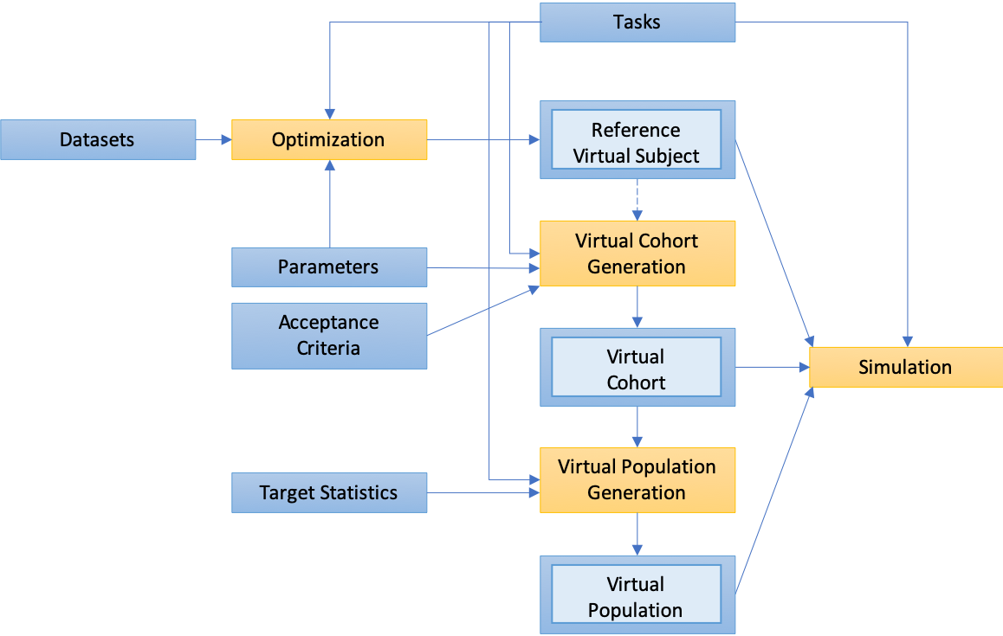

Figure S. QSP Model Development Workflow

Building blocks (blue) are used as the input to functionalities (yellow). The reference Virtual Subject, Virtual Cohort, and Virtual Population (two-toned blue boxes) are the three types of virtual subject(s) building block. In this workflow, Optimizations require a Dataset, Tasks, and Parameters and produce a reference Virtual Subject. Virtual Cohort Generations take Parameters and Acceptance Criteria to produce a Virtual Cohort. Virtual Population Generations take Tasks, a Virtual Cohort and Target Statistics to produce a Virtual Population. And Simulation functionality can be used to simulate tasks with any type of Virtual Subject(s) building block (i.e., a reference Virtual Subject, Virtual Cohort, or Virtual Population). In all four functionalities, the results are stored, and plotted using the visualization window. Reference Virtual Subjects are not used directly for Cohort Generation. Instead, the reference Virtual Subject can be used to help define parameter ranges within the Parameters building block, which is then used for Virtual Cohort Generation.

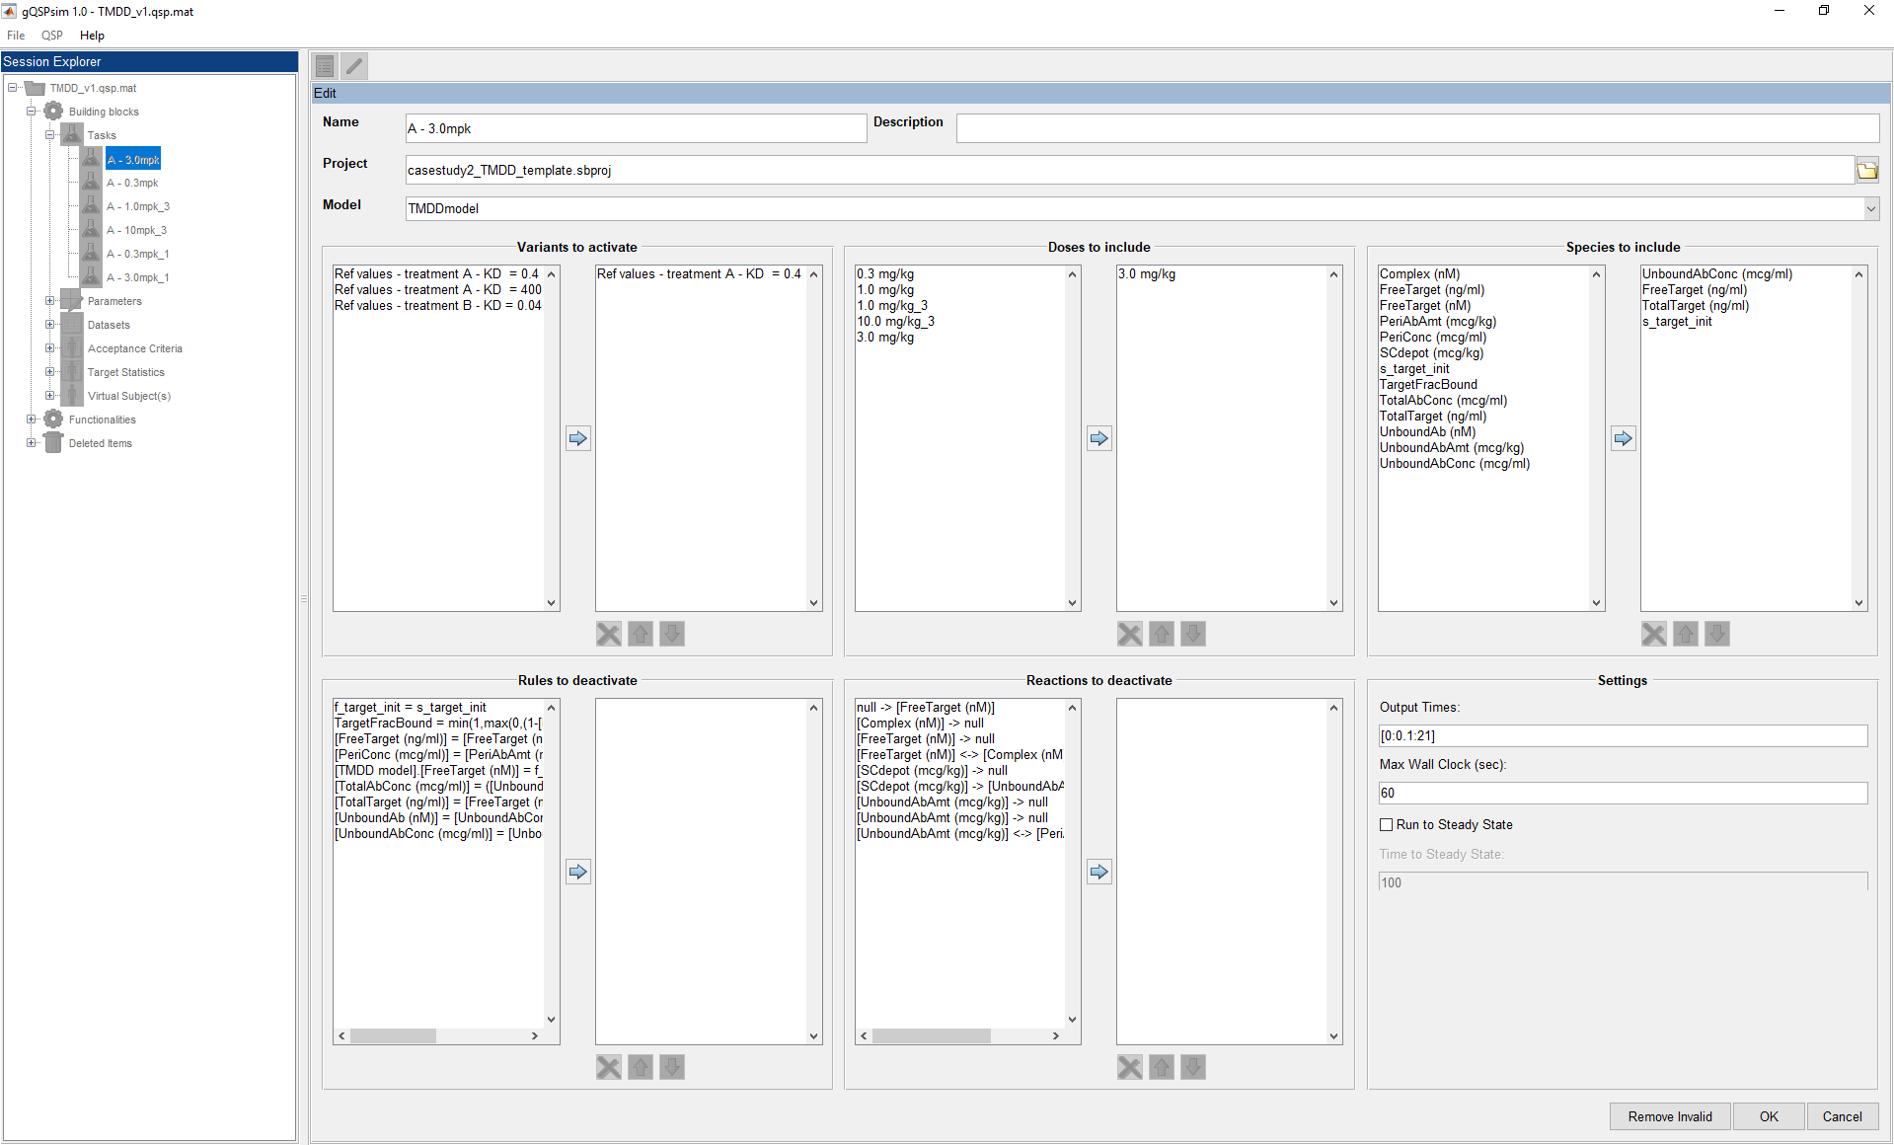

Figure S. gQSPSim: Edit View of the Task Building Block.

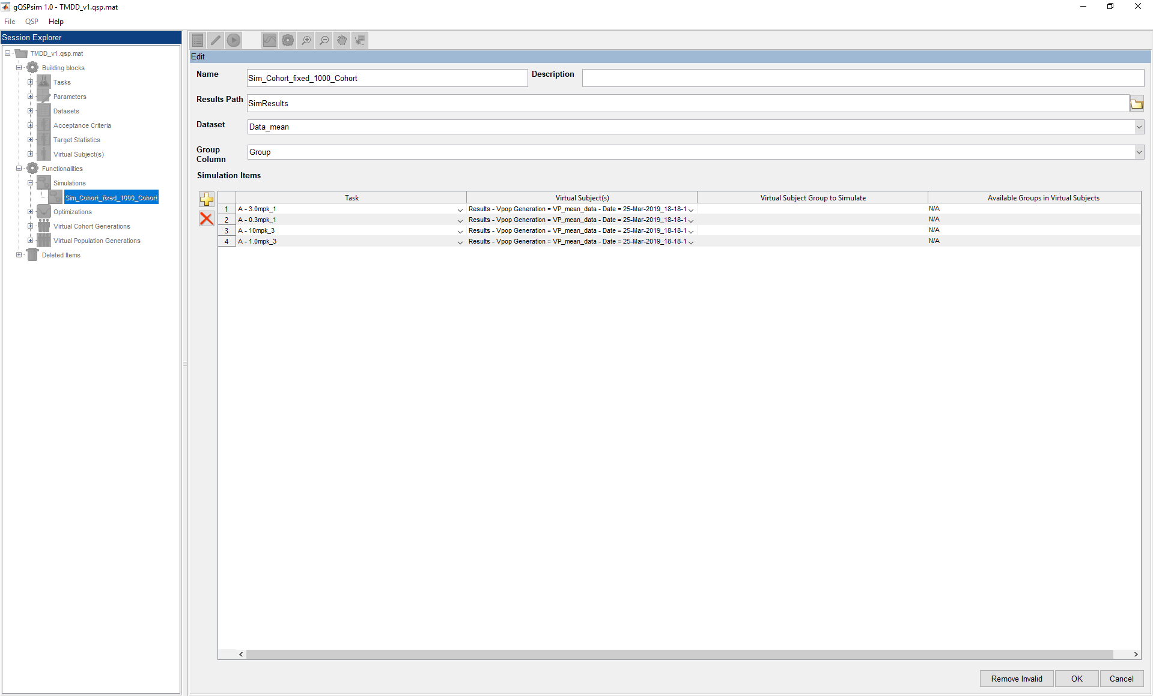

Figure S. gQSPSim: Edit View of the Simulation Functionality.

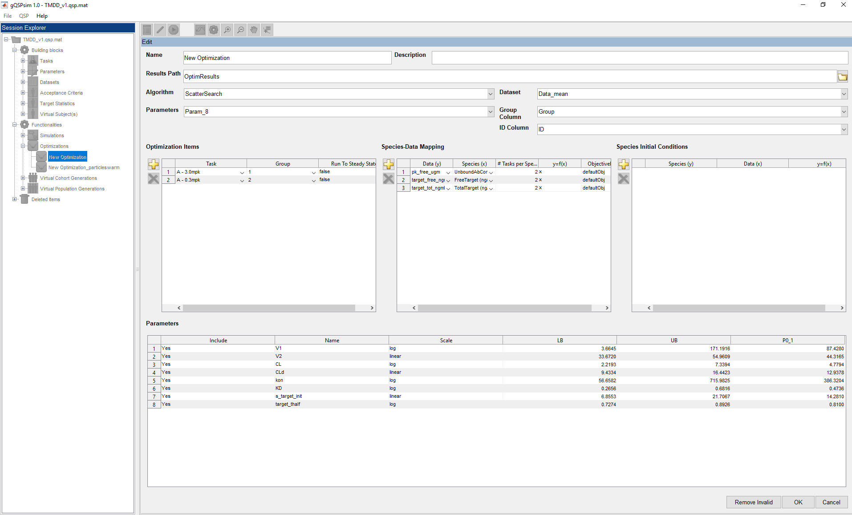

Figure S. gQSPSim: Edit View of the Optimization Functionality.

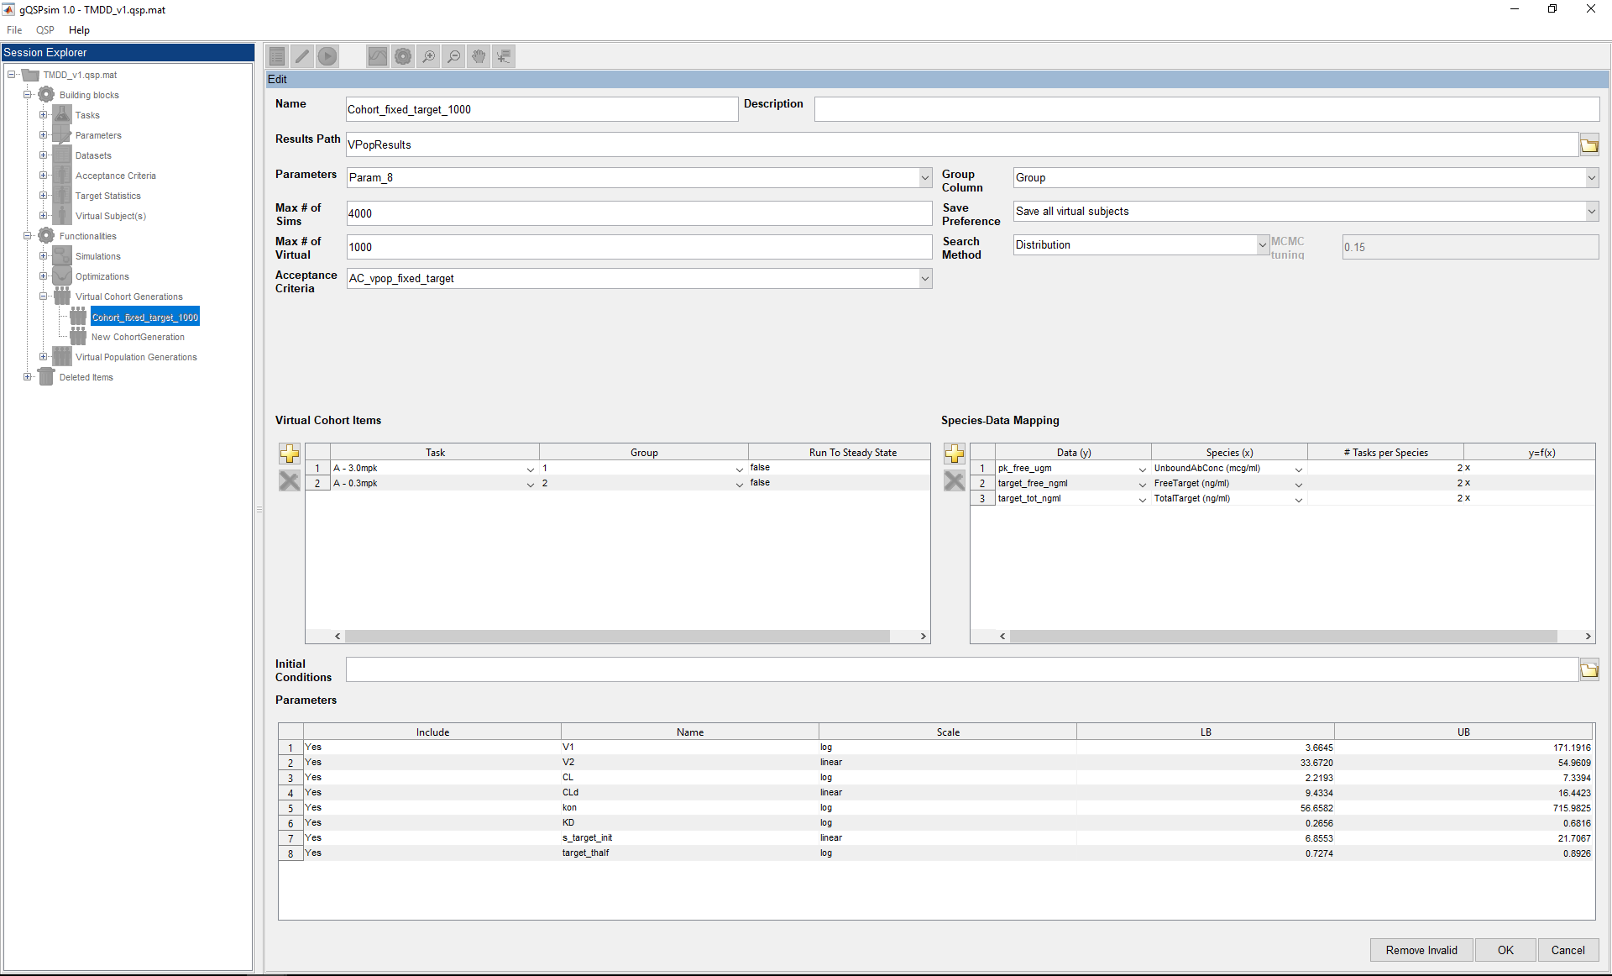

Figure S. gQSPSim: Edit View of Virtual Cohort Generation Functionality.

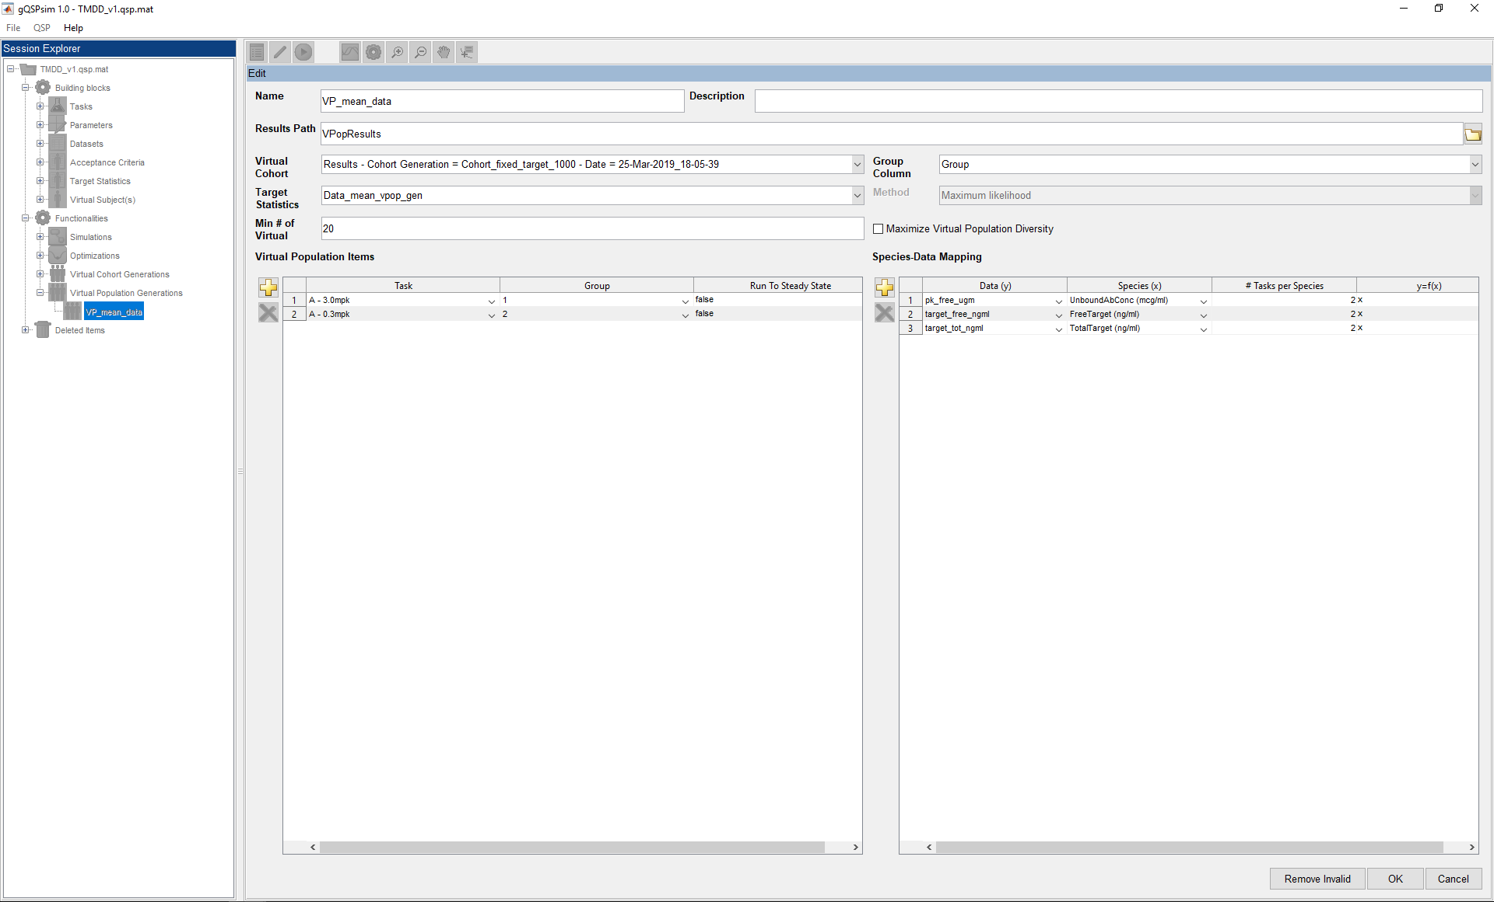

Figure S. gQSPSim: Edit View of Virtual Population Generation Functionality.

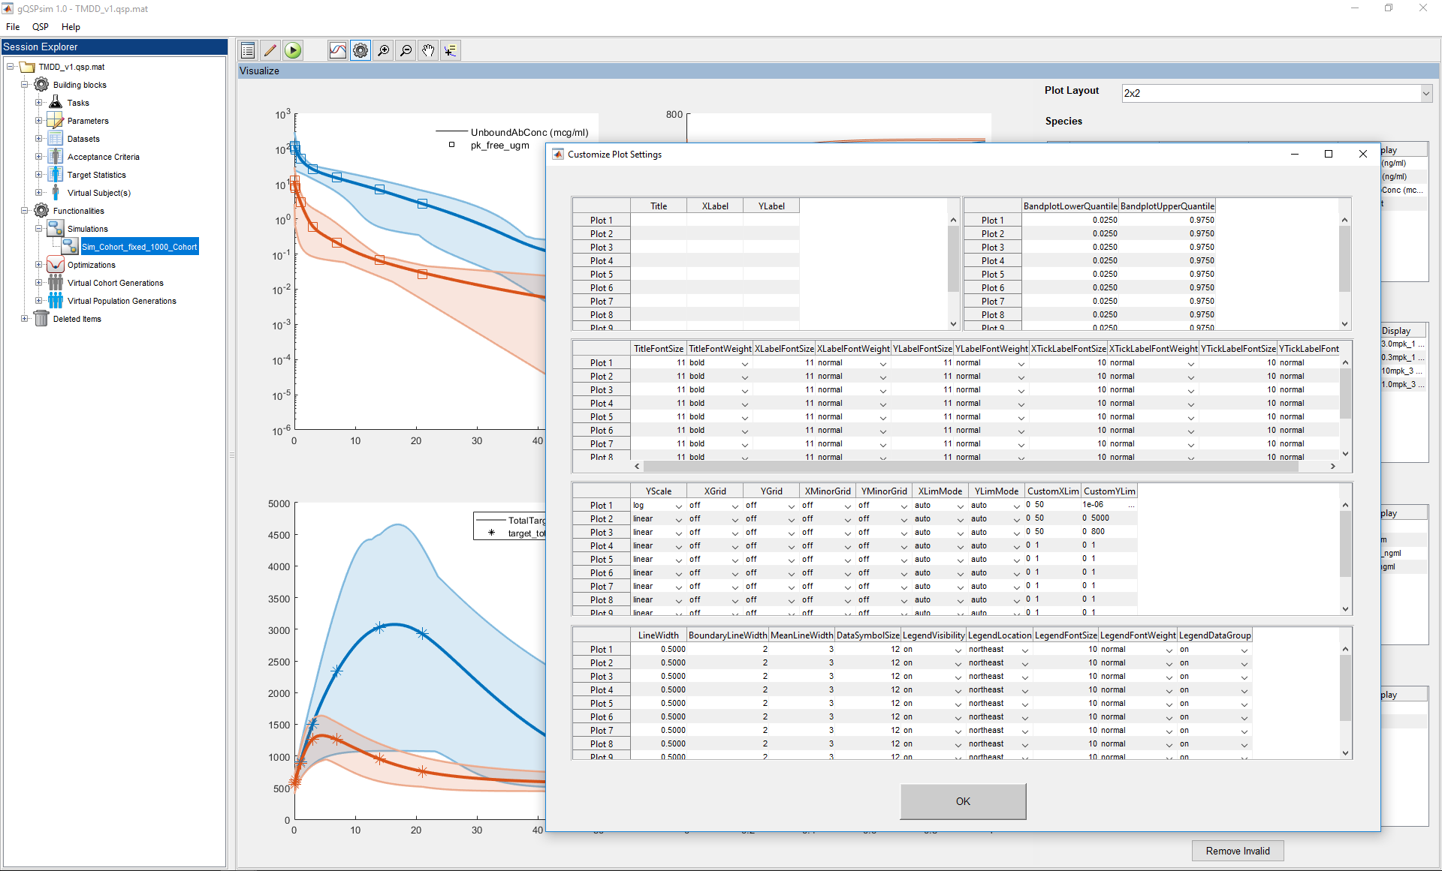

Figure S. gQSPSim: Extended Plot Settings Window

The extended plot settings window () is available in the visualization view of each of the four functionalities. It allows the user to modify various plot settings, including: (row 1, left) Title/XLabel/YLabel, (row 1, right) lower and upper quantiles for the shaded regions, (row 2) Title and label font options, (row 3) X and Y axes properties, and (row 4) line, symbol, and legend properties.



Figure S. Case Study #1: Simulation Results with Model Default Parameter Values

Simulation results for (A) free drug, (B) free target, and (C) total target using model default parameter values compared to model outputs simulated using parameters obtained from PSO and SSO optimization algorithms. The data is represented by symbols. Note that the results for SSO and PSO gave identical performances.



Figure S. Case Study #1: Virtual Cohort Generation Diagnostic View.

These plots show the distribution of the simulated (A) free drug, (B) free target and (C) total target concentrations for the valid subjects (Virtual Subjects that satisfy the Acceptance Criteria) at each time point compared to the Acceptance Criteria.

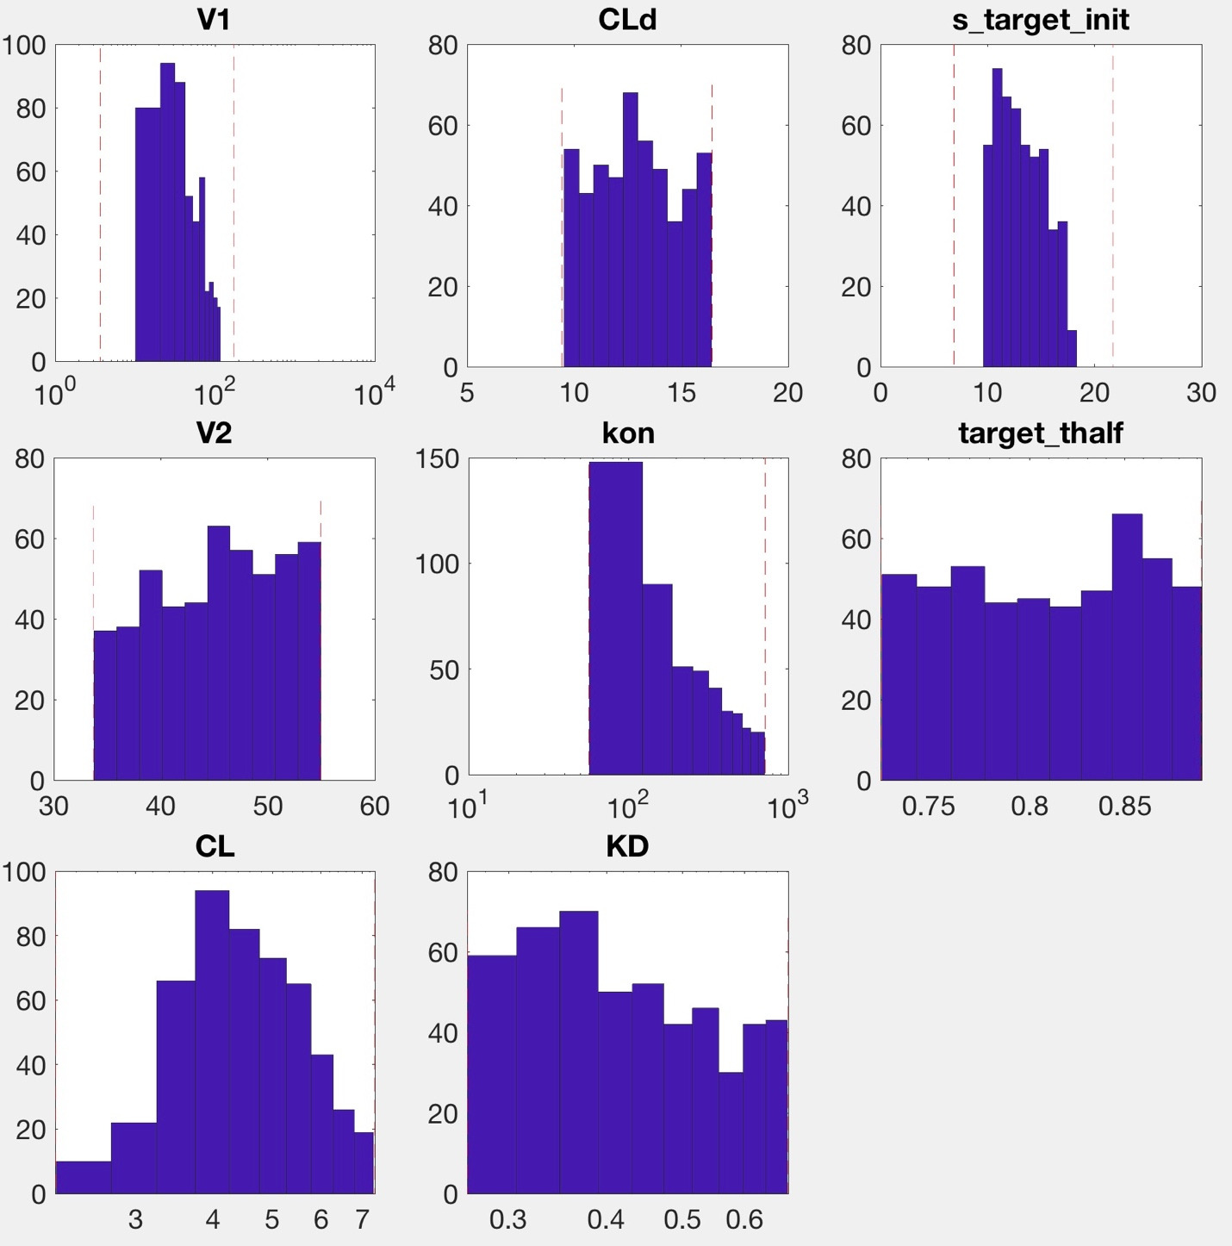

Figure S. Case Study #1: Virtual Cohort Generation Parameter Distribution View.

These plots can provide insights into the distribution of parameter values for the Virtual Subjects that satisfy the Acceptance Criteria (valid Virtual Subjects are shown here).



Figure S. Case Study #1: Virtual Cohort Generation Results Including Invalid Virtual Subjects.

The results from Virtual Cohort Generation for the following species: (A) free drug, (B) free target, and (C) total target concentrations. In each plot, the solid line represents the weighted median, the shaded region represents the 2.5th and 97.5th percentile and the symbols represent the upper and lower bound of the Acceptance Criteria. The grey dotted lines represent the Virtual Subjects that do not satisfy the Acceptance Criteria (invalid Virtual Subjects).



Figure S. Case Study #1: Virtual Cohort Generation Results with Group-Specific Initial Target Concentrations.

The results from Virtual Cohort Generation with group-specific initial target concentration for the following species: (A) free drug, (B) free target, and (C) total target concentrations. In each plot, the solid line represents the weighted median, the shaded region represents the 2.5th and 97.5th percentile, and the symbols represent the upper and lower bound of the Acceptance Criteria.



Figure S. Case Study #1: Simulation Results with Group-Specific Virtual Population.

Simulation results for the (A) free drug, (B) free target, and (C) total target concentrations using specific groups from the Virtual Population. In each plot, the solid line represents the weighted mean, the shaded region represents the 2.5th and 97.5th percentile, and the symbols represent the mean data.

C:\Users\susilom1\AppData\Local\Microsoft\Windows\INetCache\Content.Word\Fig_CheckSS_Sim_v2.tif

Figure S. Case Study #2: Simulation Results to Find the Time to Steady State.

One hundred randomly selected Virtual Subjects are simulated without dose for 500 days. Simulation results suggest that both (A) total PCSK9 and (B) total LDLc qualitatively reach steady state by day 300. Therefore, the time to steady state was chosen to be 300 days.

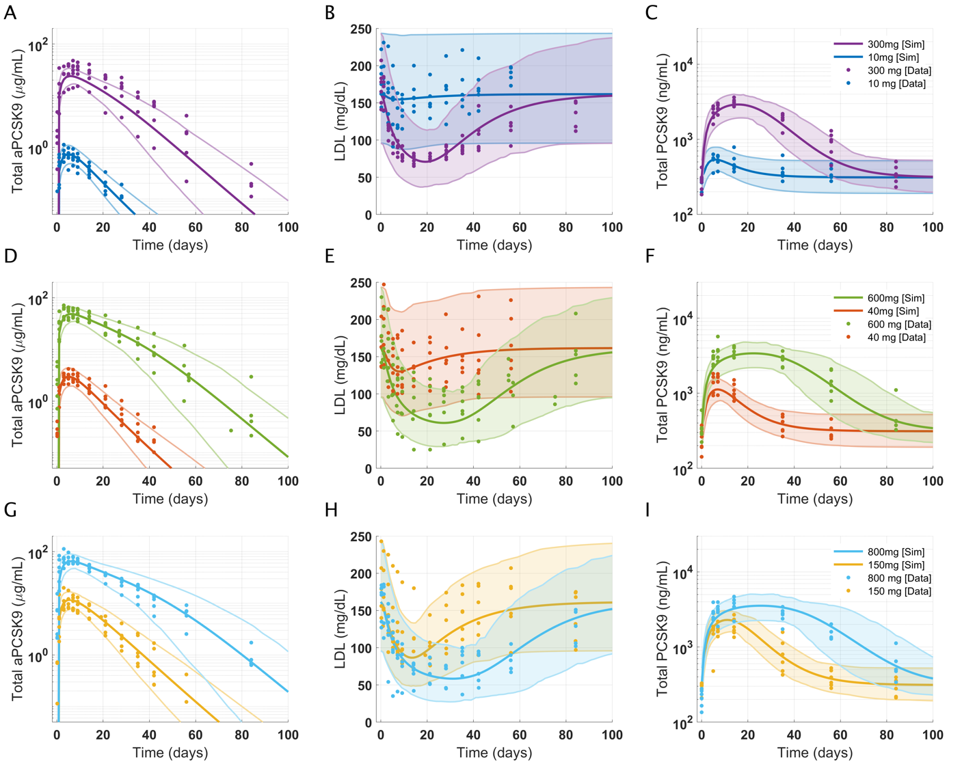

Figure S. Case Study #2: Virtual Cohort Generated for anti-PCSK9 Model.

The range of observed clinical data is well-captured by the Virtual Cohort generated using the workflow in gQSPSim. The thicker line represents the median and the shaded region represents 2.5% to 97.5% percentile of the Virtual Cohort.



Figure S. Case Study #2: The Validation and Prediction Results for the anti-PCSK9 Model

(A-D) The model was validated using a clinical trial data where anti-PCSK9 was dosed weekly starting day 0. The four groups are: (A) 40mg anti-PCSK9 without Statin pretreatment, (B) 40mg anti-PCSK9 and pretreatment with Statin for 4 weeks prior to anti-PCSK9, (C) 150mg anti-PCSK9 without Statin, (D) 150mg anti-PCSK9 and pretreatment with Statin for 4 weeks prior to anti-PCSK9. (E-F) The Virtual Population was used to predict the (E) total anti-PCSK9 levels and (F) LDL change from baseline for different dose levels and schedule.